Aim
To write a Java program to calculate the absolute difference between the sums of the primary diagonal and secondary diagonal elements of a square matrix.

Algorithm
1 Start the program.
2 Read the size of the square matrix n.
3 Read the matrix elements into a 2D list.
4 Initialize two variables:
primarySum = 0
secondarySum = 0
5 Traverse the matrix using a loop from i = 0 to n-1:
Add element at position (i, i) to primarySum.
Add element at position (i, n-1-i) to secondarySum.
6 Compute the absolute difference using
|primarySum - secondarySum|.
7 Return the result.
8 Stop the program.

PROGRAM:

import java.io.*;
import java.math.*;
import java.security.*;
import java.text.*;
import java.util.*;
import java.util.concurrent.*;
import java.util.function.*;
import java.util.regex.*;
import java.util.stream.*;
import static java.util.stream.Collectors.joining;
import static java.util.stream.Collectors.toList;

class Result {

/*
* Complete the 'diagonalDifference' function below.
*
* The function is expected to return an INTEGER.
* The function accepts 2D_INTEGER_ARRAY arr as parameter.
*/

public static int diagonalDifference(List<List<Integer>> arr) {
// Write your code here

}

}

public class Solution {
public static void main(String[] args) throws IOException {
BufferedReader bufferedReader = new BufferedReader(new InputStreamReader(System.in));
BufferedWriter bufferedWriter = new BufferedWriter(new FileWriter(System.getenv("OUTPUT_PATH")));
int n = Integer.parseInt(bufferedReader.readLine().trim());
List<List<Integer>> arr = new ArrayList<>();
IntStream.range(0, n).forEach(i -> {
try {
arr.add(
Stream.of(bufferedReader.readLine().replaceAll("\\s+$", "").split(" "))
.map(Integer::parseInt)
.collect(toList())
);
} catch (IOException ex) {
throw new RuntimeException(ex);
}
});

int result = Result.diagonalDifference(arr);
bufferedWriter.write(String.valueOf(result));
bufferedWriter.newLine();
bufferedReader.close();
bufferedWriter.close();
}
}
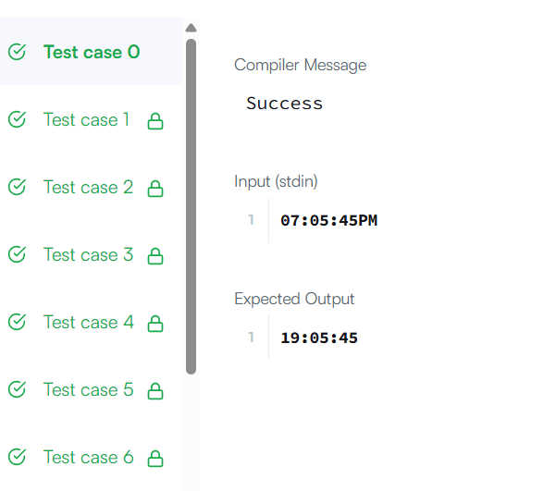

Result
The program successfully calculates and prints the absolute difference between the sums of the primary and secondary diagonals of the given square matrix.
Aim
To write a Java program to move all zero elements in an array to the end while maintaining the relative order of non-zero elements.

Algorithm
- Start the program.
- Start Take the input array nums.
- Initialize a pointer j = 0 to track the position for the next non-zero element.
- Traverse the array from i = 0 to nums.length - 1.
- If nums[i] is not equal to 0:
  - Swap nums[i] with nums[j].
  - Increment j by 1.
- Continue until the loop ends.
- Stop the program.

Program
class Solution {
public void moveZeroes(int[] nums) {
int j = 0; // Pointer to place the next non-zero element
for (int i = 0; i < nums.length; i++) {
if (nums[i] != 0) {
// Swap current element with the element at index j
int temp = nums[i];
nums[i] = nums[j];
nums[j] = temp;
j++; // Move j to the next index for placing non-zero
}
}
}
}

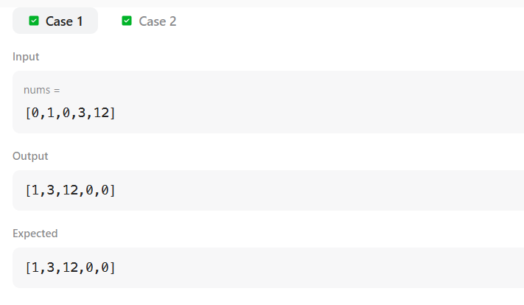

Result
The program successfully moves all zero elements to the end of the array while keeping the order of non-zero elements unchanged.

Aim
To develop a Java program that calculates the absolute difference between the sum of the primary diagonal and the sum of the secondary diagonal of a square matrix.

Algorithm
- Start the program.
- Read the integer n, representing the size of the square matrix.
- Read the matrix elements into a 2D list.
- Initialize two variables:
  - primarySum = 0
  - secondarySum = 0
- Traverse the matrix using a loop from i = 0 to n - 1:
  - Add the element at position (i, i) to primarySum.
  - Add the element at position (i, n - 1 - i) to secondarySum.
- Calculate the absolute difference using
difference = |primarySum - secondarySum|.
- Print the result.
- Stop the program.

Algorithm

import java.io.*;

import java.util.*;

import java.util.stream.*;

import static java.util.stream.Collectors.toList;

class Result {

/*

* Complete the 'diagonalDifference' function below.

* The function is expected to return an INTEGER.

* The function accepts 2D_INTEGER_ARRAY arr as parameter.

*/

public static int diagonalDifference(List<List<Integer>> arr) {

int n = arr.size();

int primarySum = 0;

int secondarySum = 0;

for (int i = 0; i < n; i++) {

primarySum += arr.get(i).get(i);

secondarySum += arr.get(i).get(n - 1 - i);

}

return Math.abs(primarySum - secondarySum);

}

}

public class Solution {

public static void main(String[] args) throws IOException {

BufferedReader bufferedReader = new BufferedReader(new InputStreamReader(System.in));

BufferedWriter bufferedWriter = new BufferedWriter(new FileWriter(System.getenv("OUTPUT_PATH")));

int n = Integer.parseInt(bufferedReader.readLine().trim());

List<List<Integer>> arr = new ArrayList<>();

for (int i = 0; i < n; i++) {

arr.add(

Stream.of(bufferedReader.readLine().trim().split(" "))

.map(Integer::parseInt)

.collect(toList())

);

}

int result = Result.diagonalDifference(arr);

bufferedWriter.write(String.valueOf(result));

bufferedWriter.newLine();

bufferedReader.close();

bufferedWriter.close();

}

}

output

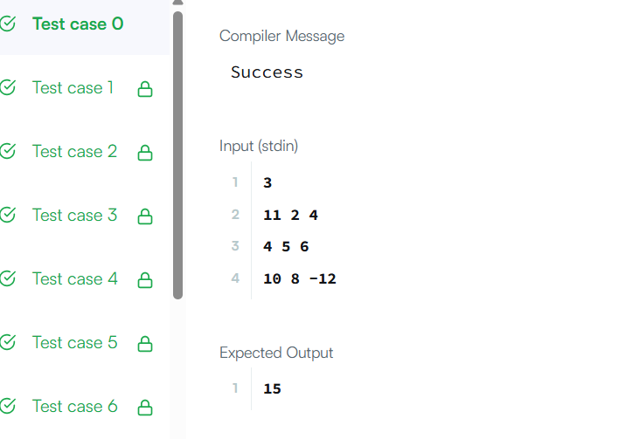

Result
The program successfully computes and displays the absolute difference between the sums of the primary and secondary diagonals of the given square matrix.

Aim
To write a Java program to find the transpose of a given matrix.

Algorithm
- Start the program.
- Read the given 2D matrix.
- Find the number of rows using matrix.length.
- Find the number of columns using matrix[0].length.
- Create a new matrix arr of size [columns][rows].
- Traverse the matrix using two nested loops:
  - Outer loop from i = 0 to columns - 1.
  - Inner loop from j = 0 to rows - 1.
- Assign arr[i][j] = matrix[j][i].
- Return the new matrix.
- Stop the program.

Program

class Solution {

public int[][] transpose(int[][] matrix) {

int row=matrix.length;

int col=matrix[0].length;

int arr[][]=new int[col][row];

for(int i=0;i<col;i++)

{

for(int j=0;j<row;j++)

{

arr[i][j]=matrix[j][i];

}

}

return arr;

}

}

Output
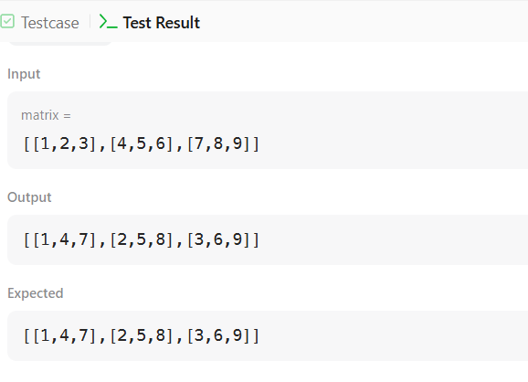

Result
The program successfully computes and returns the transpose of the given matrix

